**HW 3**

NAT and ACL (ID-202424600)

S1S2 Server Router:

interface GigabitEthernet0/0

ip nat outside

interface GigabitEthernet0/1

ip nat inside

S3S4 Server Router:

interface GigabitEthernet0/0

ip nat outside

interface GigabitEthernet0/1

ip nat inside

R1 Router:

interface GigabitEthernet0/0

ip nat inside

interface GigabitEthernet0/1

ip nat inside

interface Serial0/0/0

ip nat outside

R0 Router:

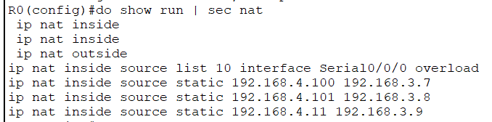

interface GigabitEthernet0/0

ip access-group yellow in

ip nat inside

interface GigabitEthernet0/1

ip access-group purple in

ip nat inside

interface Serial0/0/0

ip access-group external in

ip nat outside

DNS Server:

